**OPS102 – Week 4 – File Systems - Sample Lab**

Student Name: <Abisek Gurung>

Student ID: <135741239>

**Activity 1: Redirection and Piping**

Put following text to a file called gpt.txt

ChatGPT is an artificial intelligence chatbot developed by OpenAI and released in November 2022.

The name "ChatGPT" combines "Chat", referring to its chatbot functionality, and "GPT", which stands for Generative Pre-trained Transformer, a type of large language model.

Wikipedia

ChatGPT has been trained on huge amount of data scraped from internet.

This has enabled us to develp artificial programes that can answer questions like humans.



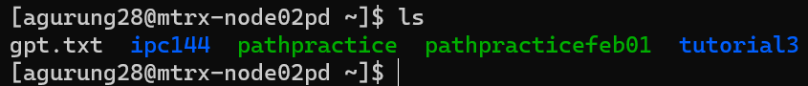

**Redirection:**

Redirection can send input to a command from a file or can send output of a command to a file.

Input redirection symbol: <

**Command < filename**

1. Run the command on Linux: **cat < gpt.txt**

What do you see and why?

= This command displays the contents of the file. It is because it reads the contents of the file in sequence and writes it in standard output

1. Run similar command on Windows: **TYPE < gpt.txt**

What do you see and why?ls

Output redirection symbol: >

**Command > filename**

1. Run the command on Linux **ls -l > list.txt**

What is the output? Explain

=The command list the content of directory in long format view in details.

1. Run equivalent command on Windows: **dir > list.txt**

What is the output? Explain

1. Run the command on both Linux and Windows: **sort < list.txt**

What is the output?

**Piping:**

**Command1 | Command2**

Piping is used to redirect output of first command to the input of the second command. This allows to combine simple commands to achieve more complex task.

Perform following tasks and add screenshots

1. On Linux run the command **ls /bin | more**

What do you see and why?

1. Suppose you have a text file called gpt.txt having following text in it

On Windows run the command **TYPE gpt.txt | FIND “GPT”**

What is the output? Explain it:

(TYPE is equivalent to cat command on Linux)

1. Run and explain the command: **cat < gpt.txt | sort > out.txt**

Explain what is happening in above command?

**Activity 2: File Permissions**

Consider following image for next tasks

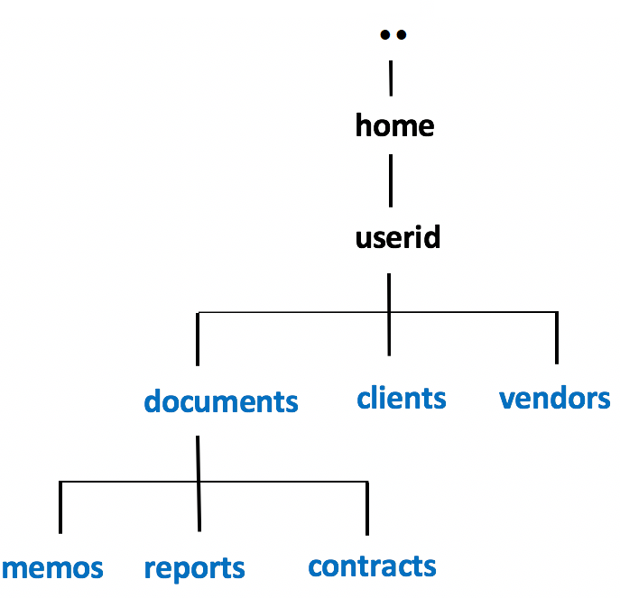

Choose any way to create following files in the respective folder

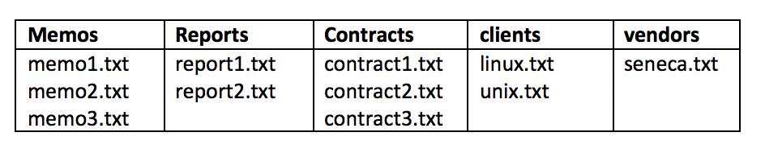

1. Issue the following Linux commands:  
   **ls -ld ~/documents ~/clients ~/vendors  
   ls -lR ~/documents ~/clients ~/vendors**
2. Let's limit access to the **clients** and **vendors** directories to only yourself and same group members.  
   Issue the following Linux command:  
   **chmod 750 ~/clients ~/vendors**
3. Issue the **ls -ld** and **ls -lR** commands (as you did in *step #8*) to confirm that the permissions for those directories have been changed.  
     
   **NOTE:** The **-R** option for the **chmod** command can change the file permissions recursively within a directory structure.
4. Issue the following Linux command: **chmod 750 -R ~/documents**
5. Issue thels
6. **ls -ld** command to confirm the permissions for the  
   **~/documents**, **~/document/memos** , **~/documents/reports**, and **~/documents/contracts** directories.
7. Issue the following Linux command: **ls -lR ~/documents**  
   What do you noticed happened to the permissions for the regular files contained in those directories.  
   Did those regular file permissions change?  
     
   We will now change permissions for regular text file contained in subdirectories  
   of the **documents** directory to: **r w - r - - - - -**
8. Issue the following Linux commands:   
   **chmod 640 ~/documents/memos/memo*.txt  
   chmod 640 ~/documents/reports/report*.txt  
   chmod 640 ~/documents/contracts/contract*.txt**
9. Issue the **ls -lR** command for the **~/documents** directory to confirm that those regular file permissions have changed.
10. Issue the following Linux command to add write permissions for all files in the memos directory  
    for yourself (i.e. user): **chmod u+w ~/documents/memos/\***

Instructor Note: Use Windows Properties to show how to change file permissions